15.54: a), b)
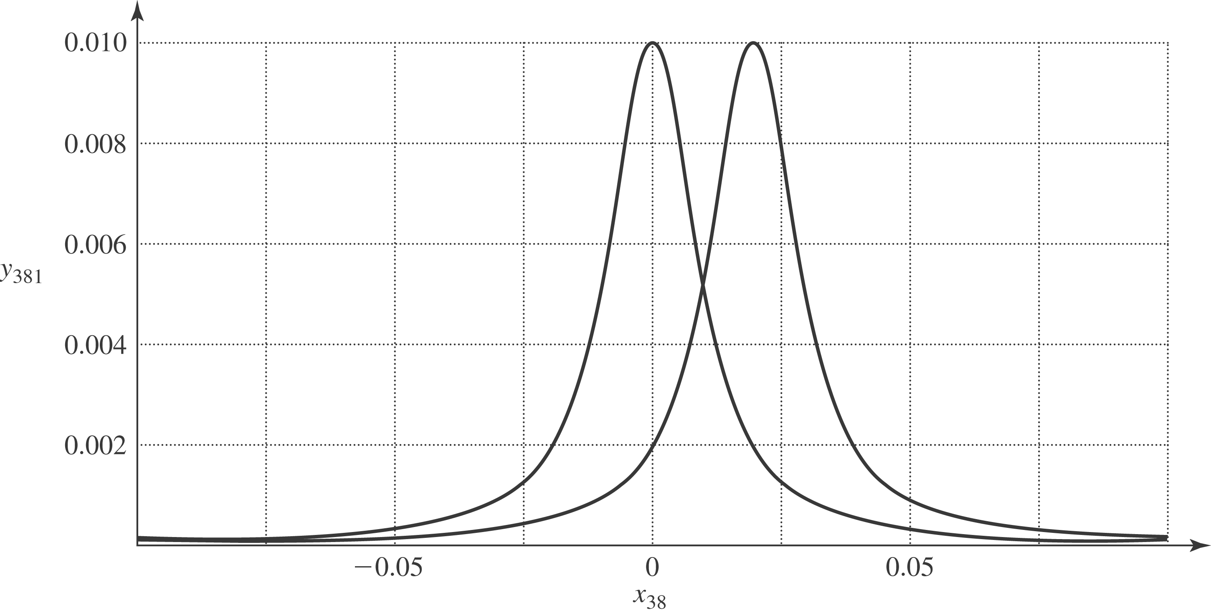

c) The displacement is a maximum when the term in parentheses in the denominator is zero; the denominator is the sum of two squares and is minimized when 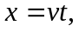and the maximum displacement is A. At 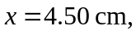the displacement is a maximum at The displacement will be half of the maximum when
d) Of the many ways to obtain the result, the method presented saves some algebra and minor calculus, relying on the chain rule for partial derivatives. Specifically, let 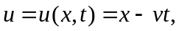 so that if 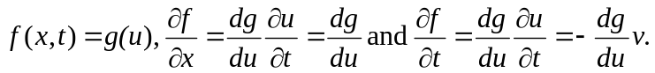 (In this form it may be seen that any function of this form satisfies the wave equation; see Problem 15.59.) In this case, 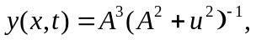 and so

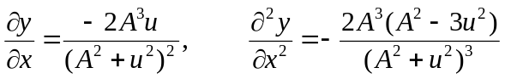

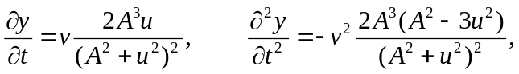

and so the given form for 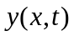 is a solution to the wave equation with speed

